CLOUDLET SCHEDULING OPTIMIZATION USING GA AND CONSENSUS ALGORITHMS.



Submitted by

Narayan Maity 11600217034
Sayantan Chatterjee 11600217013
Sayantani Maji 11600217012
Sahana Bose 11600217019
Sanjukta Dey 11600217016

Under the supervision of
(Dr. Indrajit De)

Academic Year:2020-2021

REPORT SUBMITTED IN PARTIAL FULFILLMENT OF THE REQUIREMENTS FOR THE DEGREE OFBACHELOR OF TECHNOLOGY IN INFORMATION TECHNOLOGY OF MAULANA ABUL KALAM AZAD UNIVERSITY OF TECHNOLOGY



DEPARTMENT OF INFORMATION TECHNOLOGY
MCKV INSTITUTE OF ENGINEERING
243,G.T. ROAD(NORTH),LILUAH
HOWRAH-711204

DEPARTMENT OF INFORMATION TECHNOLOGY
MCKV INSTITUTE OF ENGINEERING
243, G.T. ROAD(NORTH), LILUAH
HOWRAH-711204

CERTIFICATE OF RECOMMENDATION

We hereby recommend that the thesis prepared under our supervision by Narayan Maity
entitled CLOUDLET SCHEDULING OPTIMIZATION USING GA AND CONSENSUS ALGOITHMS
be accepted in partial fulfillment of the requirements for the degree of BACHELOR OF TECHNOLOGY IN “INFORMATION TECHNOLOGY DEPARTMENT”.

_____________________________________ ______________________
Head, Information Technology Department, Project Guide
MCKV Institute of Engineering, Howrah

DEPARTMENT OF INFORMATION TECHNOLOGY
MCKV INSTITUTE OF ENGINEERING
243,G.T. ROAD(NORTH),LILUAH
HOWRAH-711204

CERTIFICATE OF RECOMMENDATION

We hereby recommend that the thesis prepared under our supervision by Sayantan Chatterjee
entitled CLOUDLET SCHEDULING OPTIMIZATION USING GA AND CONSENSUS ALGOITHMS
be accepted in partial fulfillment of the requirements for the degree of BACHELOR OF TECHNOLOGY IN “INFORMATION TECHNOLOGY DEPARTMENT”.

_____________________________________ ______________________
Head, Information Technology Department, Project Guide
MCKV Institute of Engineering, Howrah

DEPARTMENT OF INFORMATION TECHNOLOGY
MCKV INSTITUTE OF ENGINEERING
243,G.T. ROAD(NORTH),LILUAH
HOWRAH-711204

CERTIFICATE OF RECOMMENDATION

We hereby recommend that the thesis prepared under our supervision by Sayantani Maji
entitled CLOUDLET SCHEDULING OPTIMIZATION USING GA AND CONSENSUS ALGOITHMS
be accepted in partial fulfillment of the requirements for the degree of BACHELOR OF TECHNOLOGY IN “INFORMATION TECHNOLOGY DEPARTMENT”.

_____________________________________ ______________________
Head, Information Technology Department, Project Guide
MCKV Institute of Engineering, Howrah

DEPARTMENT OF INFORMATION TECHNOLOGY
MCKV INSTITUTE OF ENGINEERING
243,G.T. ROAD(NORTH),LILUAH
HOWRAH-711204

CERTIFICATE OF RECOMMENDATION

We hereby recommend that the thesis prepared under our supervision by Sanjukta Dey
entitled CLOUDLET SCHEDULING OPTIMIZATION USING GA AND CONSENSUS ALGOITHMS
be accepted in partial fulfillment of the requirements for the degree of BACHELOR OF TECHNOLOGY IN “INFORMATION TECHNOLOGY DEPARTMENT”.

_____________________________________ ______________________
Head, Information Technology Department, Project Guide
MCKV Institute of Engineering, Howrah

DEPARTMENT OF INFORMATION TECHNOLOGY
MCKV INSTITUTE OF ENGINEERING
243,G.T. ROAD(NORTH),LILUAH
HOWRAH-711204

CERTIFICATE OF RECOMMENDATION

We hereby recommend that the thesis prepared under our supervision by Sahana Bose
entitled CLOUDLET SCHEDULING OPTIMIZATION USING GA AND CONSENSUS ALGOITHMS
be accepted in partial fulfillment of the requirements for the degree of BACHELOR OF TECHNOLOGY IN “INFORMATION TECHNOLOGY DEPARTMENT”.

_____________________________________ ______________________
Head, Information Technology Department, Project Guide
MCKV Institute of Engineering, Howrah

CERTIFICATE OF APPROVAL*
(B.Tech Degree in INFORMATION TECHNOLOGY)

This project report is hereby approved as a creditable study of an engineering subject carried out and presented in a manner satisfactory to warrant its acceptance as a pre-requisite to the degree for which it has been submitted. It is to be understood that by this approval, the undersigned do not necessarily endorse or approve any statement made, opinion expressed and conclusion drawn therein but approve the project report only for the purpose for which it has been submitted.

COMMITTEE ON FINAL 1. ----------------------------------------
EXAMINATION FOR
EVALUATION OF 2. -----------------------------------------
PROJECT REPORT
3. -----------------------------------------

4. -----------------------------------------

5. -----------------------------------------

* Only in case report is approved.

ACKNOWLEDGEMENT

It gives us immense pleasure to express our deepest sense of gratitude and regards to the persons who have contributed to our final semester project of Bachelor of Technology in Information Technology from MCKV Institute Of Engineering affiliated under Maulana Abul Kalam Azad University of Technology, West Bengal. Our experience of final year project “CLOUDLET SCHEDULING OPTIMIZATION USING GA AND CONSENSUS ALGOITHMS” has been completed successfully, and we wish to acknowledge all of them who have helped us make this project a success.
First of all, we are thankful of our project mentors Dr. Kinsuk Giri Sir and Dr Indrajit De Sir under whose guideline we were able to complete our project. We are wholeheartedly thankful to them for giving us their valuable time and attention and for providing us a systematic way for completing our project in time.
We also take this opportunity to acknowledge our HOD, Sachin Balo Sr for his constant assistance and encouragement. We would thank to our all lab maintenance staff for providing us assistance in various h/w & s/w problem encountered during course of our project.
We are also very grateful to respected Dr Indrajit De Sir for giving us the opportunity to do this magnificent project.
A special thanks to our most cooperative group without whom this project would not have been possible. We personally thanks all of our group members who have put their effort make this project a success.

Project Members-
ABSTRACT

Cloud provides convenient and on demand network access for computing resources available over internet. Individuals and organizations can access the software and hardware such as network, storage, server and applications which are located remotely easily with the help of Cloud Service. The tasks/jobs submitted to this cloud environment needs to be executed on time using the resources available so as to achieve proper resource utilization, efficiency and lesser makespan which in turn requires efficient task scheduling algorithm for proper task allocation. In this paper, we have introduced an Optimized Task Scheduling Algorithm which adapts the advantages of various other existing algorithms according to the situation while considering the distribution and scalability characteristics of cloud resources.

Keywords - Cloud Computing, Makespan, Minimum/Maximum Execution Time,

TABLE OF CONTENTS

1 INTRODUCTION AND BACKGROUND 1
1.1 CLOUD COMPUTING 1
1.2 BLOCKCHAIN 3
2 RESEARCH AGENDA 6
2.1 PURPOSE OF RESEARCH 6
2.2 REPORT PLANNING 6
3 REVIEW OF LITERATURE 7
3.1 CLOUD COMPUTING 7
3.1.1 DEFINITION 7
3.1.2 CLOUD COMPUTING ARCHITECTURE 8
3.1.3 ESSENTIAL CHARACTERISTICS OF CLOUD COMPUTING 8
3.1.4 CLOUD SERVICE MODELS 9
3.1.5 CLOUD DEPLOYMENT MODEL 10
3.1.6 CLOUD COMPUTING EVOLUTION 11
3.1.7 CLOUD COMPUTING ADOPTION 12
3.1.8 CLOUD COMPUTING AND COST 13
3.1.9 CLOUD LOAD BALANCING 13
3.2 BLOCKCHAIN 15
3.2.1 DEFINITION 15
3.2.2 CONSENSUS ALGORITHMS 16
4 CLOUD SIMULATION TOOLS 20
4.1 CLOUD ANALYST 20
4.2 CLOUDSIM 23
4.2.1 FEATURES OF CLOUDSIM 23
4.2.2 CLOUDSIM ARCHITECTURE 24
4.2.3 DESIGN AND IMPLEMENTATION OF CLOUDSIM 25
4.3 CLOUD ANALYST 30
4.3.1 FEATURES OF THE SIMULATOR 30
4.3.2 SIMULATION OUTPUT / WHAT IS BEING MEASURED 31
4.3.3 CLOUDANALYST DOMAIN MODEL & MAIN COMPONENTS 31
4.3.4 CLASS DESIGN 34
4.3.5 VM LOAD BALANCING ALGORITHM 37
4.3.6 SERVICE BROKER ALGORITHMS 39
4.3.7 CONFIGURE SIMULATION SCREEN 40
5 PREVIOUS WORK 45
5.1 OVERVIEW 45
5.2 ALGORITHM USED 45
5.2.1 SHORTEST JOB FIRST 45
5.2.2 GENETIC ALGORITHM 45
6 PREVIOUS RESULTS 47
6.1 COMPARISON 47
7 OVERVIEW OF PROPOSED ALGORITHM 48
7.1 CONSENSUS ALGORITHM 48
7.1.1 FEATURES OF CONSENSUS PROTOCOL 48
7.1.2 PROOF-OF-WORK(POW) 49
7.1.3 PROOF -OF -STAKE(POS) 49
8 REFERENCES 50

INTRODUCTION AND BACKGROUND

CLOUD COMPUTING

The impact of cloud computing on industry and end users would be difficult to overstate: many aspects of everyday life have been transformed by the omnipresence of software that runs on cloud networks. By leveraging cloud computing, start-ups and businesses are able to optimize costs and increase their offerings without purchasing and managing all the hardware and software. Independent developers are empowered to launch globally-available apps and online services. Researchers can share and analyse data at scales once reserved only for highly-funded projects. And internet users can quickly access software and storage to create, share, and store digital media in quantities that extend far beyond the computing capacity of their personal devices.

Cloud computing is the delivery of computing resources as a service, meaning that the resources are owned and managed by the cloud provider rather than the end user. Those resources may include anything from browser-based software applications (such as Tik Tok or Netflix), third party data storage for photos and other digital media (such as iCloud or Dropbox), or third-party servers used to support the computing infrastructure of a business, research, or personal project.

Before the broad proliferation of cloud computing, businesses and general computer users typically had to buy and maintain the software and hardware that they wished to use. With the growing availability of cloud-based applications, storage, services, and machines, businesses and consumers now have access to a wealth of on-demand computing resources as internet-accessed services. Shifting from on-premise software and hardware to networked remote and distributed resources means cloud users no longer have to invest the labor, capital, or expertise required for buying and maintaining these computing resources themselves. This unprecedented access to computing resources has given rise to a new wave of cloud-based businesses, changed IT practices across industries, and transformed many everyday computer-assisted practices. With the cloud, individuals can now work with colleagues over video meetings and other collaborative platforms, access entertainment and educational content on demand, communicate with household appliances, hail a cab with a mobile device, and rent a vacation room in someone’s house.

Many aspects of cloud computing can be traced as far back as the 1950s, when universities and companies rented out computation time on mainframe computers. At the time, renting was one of the only ways to access computing resources as computing technology was too large and expensive to be owned or managed by individuals. By the 1960s, computer scientists like John McCarthy of Stanford University and J.C.R Licklider of The U.S. Department of Defense Advanced Research Projects Agency (ARPA) began proposing ideas that anticipated some of the major features of cloud computing today, such as the conceptualization of computing as a public utility and the possibility of a network of computers that would allow people to access data and programs from anywhere in the world.
Cloud computing, however, didn’t become a mainstream reality and a popular term until the first decade of the 21st century. This decade saw the launch of cloud services like Amazon’s Elastic Compute (EC2) and Simple Storage Service (S3) in 2006, Heroku in 2007, Google Cloud Platform in 2008, Alibaba Cloud in 2009, Windows Azure (now Microsoft Azure) in 2010, IBM’s SmartCloud in 2011, and DigitalOcean in 2011. These services allowed existing businesses to optimize costs by migrating their in-house IT infrastructure to cloud-based resources and provided independent developers and small developer teams resources for creating and deploying apps. Cloud-based applications, known as Software as a Service (SasS) — which we’ll discuss in greater detail in the Cloud Delivery Models section — also became popular during this time period. Unlike on-premise software, or software that users need to physically install and maintain on their machines, SaaS increased the availability of applications by allowing users to access them from a variety of devices on demand.
Some of these cloud-based applications — such as Google’s productivity apps (Gmail, Drive, and Docs) and Microsoft 365 (a cloud-based version of the Microsoft Office Suite) — were offered by the same companies that launched cloud infrastructure services, while other pre-existing software products, such as Adobe Creative Cloud, were launched as cloud-based applications using the services of cloud providers. New SaaS products and businesses also emerged based on the novel opportunities of these cloud providers, such as Netflix’s streaming services in 2007, the music platform Spotify in 2008, the file-hosting service Dropbox in 2009, the video conferencing service Zoom in 2012, and the communication tool Slack in 2013. Today, cloud-based IT infrastructure and cloud-based applications have become a popular choice for both businesses and individual users and their market share is expected to grow.

BLOCKCHAIN

The concept of Blockchain first came to fame in October 2008, as part of a proposal for Bitcoin, with the aim to create P2P money without banks. Bitcoin introduced a novel solution to the age-old human problem of trust. The underlying blockchain technology allows us to trust the outputs of the system without trusting any actor within it. People and institutions who do not know or trust each other, reside in different countries, are subject to different jurisdictions, and who have no legally binding agreements with each other, can now interact over the Internet without the need for trusted third parties like banks, Internet platforms, or other types of clearing institutions.

However, the Bitcoin white paper didn’t come out of thin air, and P2P networks are not a new phenomenon. They are rooted in the early history of the computer and Internet, building on decades of research of computer networks, cryptography, and game theory . The Bitcoin white paper resolved the problem of centralized data storage and information management. All computers in the network hold an identical copy of the ledger of transactions, which acts as a single point of reference. Storing data across a P2P network eliminates problems arising from the vulnerability of centralized servers while using different cryptographic methods to secure the network.
Blockchain hereby provides a universal state layer, a universal data set that every actor can trust, even though they might not know or trust each other. This new form of distributed data storage and management also avoids the double-spending problem of existing value transfer over the Internet. Ideas around cryptographically secured P2P networks have been discussed in the academic environment in different evolutionary stages, mostly in theoretical papers, since the 1980s. However, before the emergence of Bitcoin, there has never been a practical implementation of a P2P network that managed to avoid the double-spending problem, without the need for trusted intermediaries guaranteeing value exchange.

Double-Spending Problem: The way the Internet is designed today, one can spend the same value – issued as a digital asset – multiple times, because digital information can be copied, and copies of that same digital le can be sent from one computer to multiple other computers at the same time. Physical values, on the other hand, don’t have that problem. They cannot be easily replicated, as the parties involved in a transaction can immediately verify the physical token – a bill, a coin, or another object of value, like a commodity or a collectable. While counterfeiting physical values like bills and coins is theoretically possible, it usually requires considerable expertise, since they are designed to be hard (and expensive) to copy.

Distributed Ledger: The Bitcoin blockchain protocol introduced a mechanism of making it expensive to copy digital values. A copy of the ledger is stored on multiple devices of a cryptographically secured P2P network. The ledger is a le, also called blockchain. It maintains a continuously growing list of transaction data records, chained in blocks that are cryptographically secured from tampering and revision. In order to change the contents of that ledger, network users need to reach a mutual agreement, also referred to as consensus. Blockchain can, therefore, be described as a shared, trusted, public ledger of transactions, that everyone can inspect, but which no single user controls. The ledger is built as a linked list – or chain of blocks – where each block contains a certain number of transactions that were validated by the network in a given timespan. Each block furthermore includes the cryptographic hash of the prior block in the blockchain, linking one block with another into a chain of blocks, which guarantees the integrity of the previous block all the way back to the first block, the genesis block. Since the ledger records transactions across many computers, data on the blockchain cannot be altered retroactively, without the alteration of all subsequent blocks.

Unlike distributed databases, where data is distributed but managed and controlled by one single entity, blockchains allow for distributed control. Different people and institutions, that do not trust each other, share information without requiring a central administrator. Each independent node has the latest version of the ledger, which contains all transactions that have ever been made, and can verify transactions. This is particularly useful in inter-organizational setups where no institution wants to trust another institution with the management of their data.

Like a spreadsheet in the cloud: The ledger could also be described as a spreadsheet in the cloud. For example, Google Sheets: everyone can access and simultaneously edit the same le. But as opposed to Google Sheets, where that le is centrally stored on the Google servers, the blockchain ledger is a document that is not centrally stored. Instead, each node of the network keeps an identical copy of the same le at all times (with temporary exceptions every time a new block is created). Every computer in the network manages its own identical copy of the ledger. This is creating a unique data set (state) across the whole network.

Universal State Layer: The ledger, which is stored on all the computers of the network, guarantees that each unit of value was transferred only once. It acts as a digital notary and a publicly verifiable timestamp. This allows us to replace the role of many trusted intermediaries, securely managing and verifying information, bypassing many problems of the walled gardens of client-server architecture, of the current Internet architecture. The Bitcoin blockchain protocol, therefore, introduced a new form of data management in the backend of the Internet.

Distributed Consensus: “Proof-of-Work” is the consensus mechanism that enables distributed control over the ledger. It is based on a combination of economic incentives and cryptography. Reverse game theory is used to reward network actors with a native network token. In the case of the Bitcoin Network, this would be the Bitcoin token. This reward mechanism is designed to make it economically infeasible to cheat the network, taking into account even more extreme attack scenarios. “Proof-of-Work” makes it exceedingly di cult to falsify the blockchain, due to the prohibitively large amount of computing power that would be required to do so. Blockchains, therefore, offer traceability as well as higher statistical security against counterfeiting than conventional information systems, without the need for trusted intermediaries. Statistical counterfeiting protection refers to the fact that manipulation of the system becomes very expensive and therefore unlikely, thanks to the underlying economic mechanisms.

RESEARCH AGENDA

As Cloud Computing is one of the most talked about technologies now days and it has great importance in enterprises because of the cost and computational promises it offers. We will conduct the research on the issue of Cloud Computing and Enterprises. There are different scheduling algorithms available and we will study them to answer proposed research agenda which is:
“CLOUDLET SCHEDULING OPTIMIZATION USING GA AND CONSENSUS ALGOITHMS”

PURPOSE OF RESEARCH

The purpose of the thesis is to find out the benefits and drawbacks in regards with cost, data security and data availability, organizations can have by the use of Cloud Computing for the implementation and management of their information system. Finally concluding the factors in terms of cost and data security which an organization should keep in mind while adopting Cloud Computing for the effective and efficient use of their information system and also, we will try to modify or come up with more efficient algorithms for task scheduling in cloud computing environment.

REPORT PLANNING

So far, we have completed half of this project.and A review of the previous work is briefly described in the section 2.4 of this paper and the rest of the work is described in the section 3. This project report has been divided into various chapters, sections, sub-sections and sub sub-sections. The present chapter describes a brief introduction which includes introduction and historical background, research agenda and purpose of research. Chapter 2 gives a brief review of the current project and completed work. In Chapter 3, we have described proposed algorithms. Chapter 4 describes the results and subsequent analysis using classical algorithms and proposed algorithm. Finally, the concluding remarks are given in Chapter 5.

REVIEW OF LITERATURE

The aim of this part is to review and analyze the previous work completed with respect to this topic and to introduce the theoretical framework of proposed research work.

CLOUD COMPUTING

This section briefly describes the cloud environment or Cladism in detail and the process flow and inner computations undergoing during simulation and describes the process of configuring clouds.

DEFINITION

The National Institute of Standards and Technology (NIST), a non-regulatory agency of the United States Department of Commerce with a mission to advance innovation, defines cloud computing as:
a model for enabling ubiquitous, convenient, on-demand network access to a shared pool of configurable computing resources (e.g., networks, servers, storage, applications, and services) that can be rapidly provisioned and released with minimal management effort or service provider interaction.
NIST lists the following as the five essential characteristics of cloud computing:
On-demand self-service: Cloud resources can be accessed or provisioned without human interaction. With this model, consumers can gain immediate access to cloud services upon signup. Organizations can also create mechanisms for allowing employees, customers, or partners to access internal cloud services on demand according to predetermined logics without needing to go through IT services.
Broad network access: Users can access cloud services and resources through any device and in any networked location provided that they have permission.
Resource pooling: Cloud provider resources are shared by multiple tenants while keeping the data of individual clients hidden from other clients.
Rapid elasticity: Unlike on-premise hardware and software, cloud computing resources can be rapidly increased, decreased, or otherwise modified based on the cloud user’s changing needs.
Measured service: Usage of cloud resources is metered so that businesses and other cloud users need only pay for the resources they use in any given billing cycle.
These characteristics offer a wide variety of transformative opportunities for businesses and individuals alike, which we’ll discuss later in the section Benefits of Cloud Computing. To gain some additional context, let’s briefly review the emergence of cloud computing.

CLOUD COMPUTING ARCHITECTURE

Especially, for the design of system model, we have to consider several factors like cost, complexity, speed, system portability, security, etc. Cloud computing architecture varies from the traditional distributed system architecture in that 1) it is highly scalable, 2) it is an abstract entity and addresses distinct levels of services to the cloud consumer, 3) economies of scale control it and 4) it delivered on dynamic demand services through virtualization.

ESSENTIAL CHARACTERISTICS OF CLOUD COMPUTING

As described above, there are 5 essential characteristics of Cloud Computing which explains their relation and difference from the traditional computing.

On-demand-self-service Consumer can provision or un-provision the services when needed, without the human interaction with the service provider.
Broad Network Access It has capabilities over the network and accessed through standard mechanism.
Resource Pooling The computing resources of the provider are pooled to serve multiple consumers which are using a multi-tenant model, with various physical and virtual resources dynamically assigned, depending on consumer demand.
Rapid Elasticity Services can be rapidly and elastically provisioned.
Measured Service Cloud Computing systems automatically control and optimize resource usage by providing a metering capability to the type of services (e.g. storage, processing, bandwidth, or active user accounts).

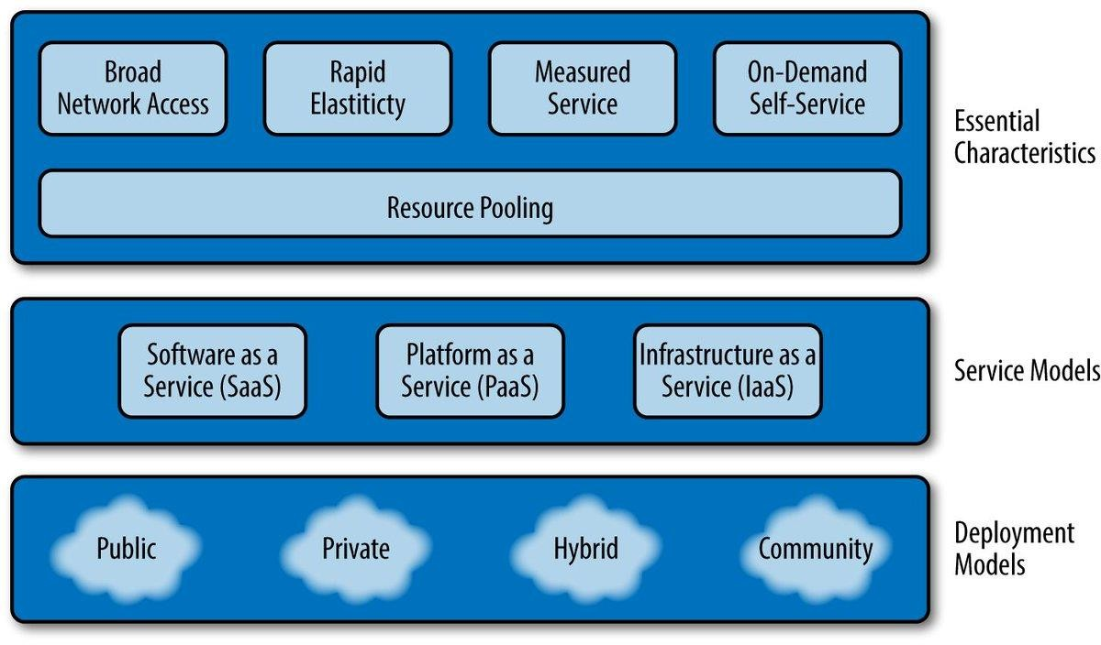

Fig 1: The NIST Visual Model of Cloud Computing

CLOUD SERVICE MODELS

Cloud resources are provided in a variety of different delivery models that offer customers different levels of support and flexibility.

INFRASTRUCTURE AS A SERVICE (IaaS)
IaaS is the on-demand delivery of computing infrastructure, including operating systems, networking, storage, and other infrastructural components. Acting much like a virtual equivalent to physical servers, IaaS relieves cloud users of the need to buy and maintain physical servers while also providing the flexibility to scale and pay for resources as needed. IaaS is a popular option for businesses that wish to leverage the advantages of the cloud and have system administrators who can oversee the installation, configuration, and management of operating systems, development tools, and other underlying infrastructure that they wish to use. However, IaaS is also used by developers, researchers, and others who wish to customize the underlying infrastructure of their computing environment. Given its flexibility, IaaS can support everything from a company’s computing infrastructure to web hosting to big data analysis.

PLATFORM AS A SERVICE (PaaS)
PaaS provides a computing platform where the underlying infrastructure (such as the operating system and other software) is installed, configured, and maintained by the provider, allowing users to focus their efforts on developing and deploying apps in a tested and standardized environment. PaaS is commonly used by software developers and developer teams as it cuts down on the complexity of setting up and maintaining computer infrastructure, while also supporting collaboration among distributed teams. PaaS can be a good choice for developers who don’t have the need to customize their underlying infrastructure, or those who want to focus their attention on development rather than DevOps and system administration.

SOFTWARE AS A SERVICE (SAAS)
SaaS providers are cloud-based applications that users access on demand from the internet without needing to install or maintain the software. Examples include GitHub, Google Docs, Slack, and Adobe Creative Cloud. SaaS applications are popular among businesses and general users given that they’re often easy to adopt, accessible from any device, and have free, premium, and enterprise versions of their applications. Like PaaS, SaaS abstracts away the underlying infrastructure of the software application so that users are only exposed to the interface they interact with.

CLOUD DEPLOYMENT MODEL

Cloud services are available as public or private resources, each of which serves different needs.

PUBLIC CLOUD
The public cloud refers to cloud services (such as virtual machines, storage, or applications) offered publicly by a commercial provider to businesses and individuals. Public cloud resources are hosted on the commercial provider’s hardware, which users access through the internet. They are not always suitable for organizations in highly-regulated industries, such as healthcare or finance, as public cloud environments may not comply with industry regulations regarding customer data.

PRIVATE CLOUD
The private cloud refers to cloud services that are owned and managed by the organization that uses them and available only to the organization’s employees and customers. Private clouds allow organizations to exert greater control over their computing environment and their stored data, which can be necessary for organizations in highly-regulated industries. Private clouds are sometimes seen as more secure than public clouds as they are accessed through private networks and enable the organization to directly oversee their cloud security. Public cloud providers sometimes provide their services as applications that can be installed on private clouds, allowing organizations to keep their infrastructure and data on premise while taking advantage of the public cloud’s latest innovations.

HYBRID CLOUD AND MULTICLOUD
Many organizations use a hybrid cloud environment which combines public and private cloud resources to support the organization’s computing needs while maintaining compliance with industry regulation. Multicloud environments are also common, which entail the use of more than one public cloud provider (for example, combining Amazon Web Services and DigitalOcean).

CLOUD COMPUTING EVOLUTION

Embracing cloud computing solutions is becoming increasingly paramount for organizations looking to drive their business forward over the coming years, with the roles of CTOs and CIOs having to evolve in step. Over the past decade, cloud computing adoption has seen explosive growth – at both consumer and enterprise levels. Legacy software providers such as Microsoft, Oracle and Adobe have all made huge, concerted efforts to encourage users of their on-premises software offerings to upgrade to their cloud equivalents, which are usually offered on a subscription pay-as-you-go basis. At the same time, we have seen a cornucopia of cloud-native providers – such as Zendesk, Workday and ServiceNow – emerge with Software as a Service (SaaS) offerings that are (and have always been) only available in the cloud. And it’s not only Software as a Service that has emerged, of course, but Platform as a Service (PaaS), Infrastructure as a Service (IaaS), Backup as a Service (BaaS) and Disaster Recovery as a Service (DRaaS) as well. Pretty much Everything as a Service (or XaaS, as it is peddled by companies like Google and Microsoft who offer such holistic resources) is now available. Where is cloud computing going? 1. The Number of Cloud-based Services and Solutions Will Continue to Rise. 2. Hybrid and Multi-Cloud Strategies Will Play a Key Role. 3. Security and Compliance Will Be Critical.
Table 1: Difference between Grid and Cloud Computing

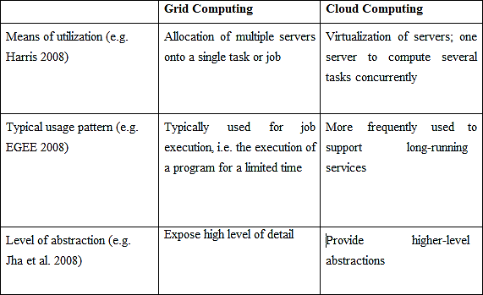

CLOUD COMPUTING ADOPTION

Cloud Computing is also about how IT is provisioned and used and not only about technological improvements of datacenter. Enterprises must consider the benefits, drawbacks and other effects of Cloud Computing on their enterprises and usage practices before adopting and using Cloud Computing. In enterprises, the adoption of Cloud Computing is much dependent on the maturity of organizational and cultural processes as the technology per sec. Some predict that adoption of Cloud Computing is not going to happen overnight, rather it could take 10 to 15 years before typical enterprise make this shift. Hence, we are currently at the start of a transition period during which many decisions need to be made with respect to adoption of Cloud Computing in the enterprise. The decision to adopt Cloud Computing is challenging because of the range of practical and socio-political reasons. It is not possible that all enterprises outsource their whole backend computing requirements to cloud providers rather; they will establish a heterogeneous computing environment which is based on dedicated servers, organizational clouds and possibly more than one public cloud provider. How the adoption to Cloud Computing is managed does not only depend on technical issues but also on socio-technical factors (i.e. cost, confidentiality and control), the impact on work practices and constraints derivedfrom existing business models.

Hence, the challenges that enterprises must address before Cloud Computing adoption are: -

- To provide accurate information on costs of cloud adoption
- To support risk management
- To ensure that decision makers can make informed trade-offs between the benefits and risks.

CLOUD COMPUTING AND COST

The economic appeal of Cloud Computing is often mentioned as “converting capital expenses to operating expenses”. Enterprises using Cloud Computing pay differently depending on the agreement between them and the Cloud Computing providers. Usually Cloud Computing providers have detailed costing models which are used to bill users on pay per use basis. There are different cost models available in the market for Cloud Computing. However, the most used model is discussed by AmTrust, which is a short-term billing model. Armbrust describes the short-term billing model as one of the most interesting and novel features of Cloud Computing. Researchers have discussed the economics of Cloud Computing in two respects i.e. Consumer Perspective and Provider Perspective. Both the perspectives have different cost/price models. [12]

CLOUD LOAD BALANCING

Cloud Load balancing is the process of distributing workloads and computing resources across one or more servers. This kind of distribution ensures maximum throughput in minimum response time. The workload is segregated among two or more servers, hard drives, network interfaces or other computing resources, enabling better resource utilization and system response time. Thus, for a high traffic website, effective use of cloud load balancing can ensure business continuity. The common objectives of using load balancers are:

- To maintain system firmness.
- To improve system performance.
- To protect against system failures.
Here, load refers to not only the website traffic but also includes CPU load, network load and memory capacity of each server. A load balancing technique makes surethat each system in the network has same amount of work at any instant of time. This means neither any of them is excessively over-loaded, nor under-utilized.
Some of the advantages of cloud load balancing are:

- High Performing applications:Cloud load balancing techniques, unlike their traditional on-premise counterparts, are less expensive and simple to implement. Enterprises can make their client applications work faster and deliver better performances, that too at potentially lower costs

- Increased scalability:Cloud balancing takes help of cloud’s scalability and agility to maintain website traffic. By using efficient load balancers, you can easily match up the increased user traffic and distribute it among various servers or network devices. It is especially important for ecommerce websites, who deals with thousands of website visitors every second. During sale or other promotional offers they need such effective load balancers to distribute workloads.

- Ability to handle sudden traffic spikes:A normally running University site can completely go down during any result declaration. This is because too many requests can arrive at the same time. If they are using cloud load balancers, they do not need to worry about such traffic surges. No matter how large the request is, it can be wisely distributed among different servers for generating maximum results in less response time.

- Business continuity with complete flexibility:The basic objective of using a load balancer is to save or protect a website from sudden outages. When the workload is distributed among various servers or network units, even if one node fails the burden can be shifted to another active node.

BLOCKCHAIN

This section briefly describes the blockchain in detail

DEFINITION

A blockchain is a digital, public ledger that records online transactions. Blockchain is the core technology for cryptocurrencies like bitcoin. A blockchain ensures the integrity of a cryptocurrency by encrypting, validating, and permanently recording transactions. A blockchain is similar to a bank’s ledger, but open and accessible to everyone who utilizes the cryptocurrency is supports.

When you swipe your credit card at a store, the charge has to pass through a financial institution like a bank, which confirms the transaction, debits the cardholder’s account, and relays the charge to the retailer to complete the sale. This can be expensive — banks charge a fee for the service — and insecure for users, as recent hacks on Target’s point-of-sale systems have shown. There is also the potential for credit card fraud, which costs merchants in the U.S. hundreds of millions of dollars a year.

The blockchain fixes these issues. As it’s name suggests, a blockchain is made up of a series of “blocks.” The blockchain software records each transaction in a block without the aid of a third party like a bank or payment processor. The blockchain algorithm automatically encrypts and authenticates the transaction, which is immediately visible to all users, minimizing the possibility of fraud. The terms of the transaction do not include any personal or identifying information.

Blockchain technology was invented to govern bitcoin, the first and most popular cryptocurrency. Some newer platforms, like ethereum, employ a blockchain to provide a digital ecosystem for distributed computing, effectively using cryptocurrency to oil the works. In ethereum, blocks run what’s called a smart contract to ensure that certain conditions are met before a service is rendered.

Every blockchain user has the same copy of of the entire blockchain as everybody else. This makes it virtually impossible to manipulate: a hacker would have to harness computing power greater than that of every user to alter the blockchain in her favor. Because of this ironclad security, major mainstream institutions like Citigroup and the London Stock Exchange have embraced blockchain technology, in the hope of using it, for example, to protect intellectual property or store investment records. Blockchains may even be used by artists and musicians to secure their work and receive fair compensation from fans. It may not be long before artists forego licensing their work to a publisher, who takes a cut, when they can register it directly to a blockchain.

CONSENSUS ALGORITHMS
Conventional distributed systems, as well as modern day cloud computing, perform functions suchas data storage, analysis and processing, job scheduling, processing customer requests, etc. Allthese tasks require coordination and consensus between the component resources [8]. Consensusand coordination are required for achieving efficient resource management, replication, atomicityand ultimately - service delivery. This has given rise to a need for standardized consensus andcoordination algorithms that can be applied in the context of both distributed systems and cloudcomputing. Over the years, several algorithms have been proposed and widely researched. Paxosand Raft have emerged as the most widely researched and industry-adapted algorithms. Thefollowing sections provide an insight into the implementation of both these algorithms.

PAXOS
Paxos was introduced by the American computer scientist Leslie Lamport in 1989. According toAilijiang et al [8], It was one of the first formally-proven consensus algorithms that dealt with thechallenges like message loss, asynchrony, data loss, etc., in a typical distributed systemarchitecture. It rose to fame when Google incorporated it into the Google File System forimplementing a fault-tolerant coordination system, which gave birth to the GFS lock system -Google Chubby. Apache ZooKeeper provided an open source implementation of the GoogleChubby lock service, called ‘Zab,’ to address ZooKeeper’s coordination challenges.According to its original creator, Paxos was originally designed for implementing a fault tolerantdistributed system that addresses coordination and consensus challenges like asynchrony,message-loss, process crash / recovery, etc. [9]. The Paxos system is modelled on a typicalasynchronous, non-Byzantine distributed system. It consists of a collection of processes that canpropose different types of values. The consensus algorithm eventually selects only one of theseproposed values. The Paxos system operates under the following constraints: i. Only a proposedvalue can be selected; ii. Only a single value is selected; iii. The processes remain unaware of thevalue, until it actually has been chosen. The processes in the Paxos system can either be proposers,acceptors or learners, and every process can act as more than one agent. The communicationbetween these agents or processes takes place via messages called prepare request and acceptrequest. The proposer sends proposals to a set of acceptors, and each acceptor accepts the firstvalue that it receives. An acceptor can accept multiple proposals. The acceptor can only accept aproposal having a higher value than the value of the previously accepted proposal. The value thatis accepted the most by the acceptors is chosen as the winner. The learner then asks the acceptorsfor the chosen value.

RAFT
Several variants of the original Paxos consensus algorithm have been developed and used by theindustry since the former’s invention. Raft is one such algorithm developed by Stanford universitystudents, to design an algorithm that was easier to understand and implement than Paxos [10]. Raftis different than Paxos in terms of features such as log replication, management, reduced numberof states, stronger coherency, and guaranteeing safety for changing cluster memberships. Ongaroand Ousterhout claim that Raft is easier than Paxos, in terms of understanding. They also proposethat Paxos, in addition to being difficult to understand, also requires some major complex changesto enable its use in modern systems.The Raft system consists of several servers. Time is divided into terms of arbitrary integer value.Initially, all the servers begin as followers. For each term, one of the servers can be a leader andthe rest of the servers are followers. The leader handles all the clients’ requests, while the followersplay a passive role. The servers communicate with each other via Remote Procedure Calls (RPCs).A heartbeat mechanism is used by Raft, to conduct the elections. The leaders initiate anAppendEntries RPC to provide the heartbeat. During the elections, RequestVote RPCs are initiatedby the candidates. Each server can vote for only one candidate on a First-Come-First-Serve (FCFS)basis. The candidate that receives the maximum votes from majority of servers, wins the election,for the term. The leaders maintain their authority by sending periodic heartbeat messages to thefollowers. If a follower does not receive any communication from the leader for a certain time,election timeout, it initiates a new election. Apart from the leader election, Raft also providesfeatures such as log replication and safety for machine states.3. Need for Consensus Algorithms in the CloudConsensus algorithms have been used widely, since decades, to implement efficient and robustdistributed systems. These algorithms aim to achieve an agreement or consensus between entitiesor resources within a system [8]. A typical distributed network system consists of severalautonomous server nodes, where each server node is associated with its own computational powerand processing capability. Such a network system is called a datacenter and this datacenter ishosted on a cloud. Consumers avail different kinds of services from cloud service providers andthese services get processed on the cloud-based datacenters in the form of tasks. These tasks aretypically diverse in terms of dependencies, priority, processing requirements and size. The trafficconsisting of such tasks is dynamic and is handled by the cloud. To ensure efficient utilization ofresources and reliable service delivery, load balancing is very essential. Inefficient load balancingcan cause the workload to be unequally distributed to the servers which may lead to over-provisioning as well as starvation. This can lead to serious consequences such as high power-consumption, datacenter failure, slow and best-effort service delivery, etc. To achieve optimumload balancing, these component server nodes need to communicate efficiently between eachother. Thus, consensus algorithms come into play.In their paper [12], A. Loon and M. Mahyuddin have proposed a time-averaging, dynamic loadbalancing consensus algorithm that takes into consideration network scalability and provides aflexible mapping to diverse network topologies. This algorithm has been modelled on a networkconsisting of server nodes. This network supports fast consensus convergence rate and scalability.However, this algorithm has been proposed in the context of a distributed network. The challengeis to design a load balancing consensus algorithm in the context of the cloud.4. Consensus Algorithms in Industry ApplicationsMarandi et al [11] have evaluated four open-source versions of Paxos - S-Paxos, OpenReplica,Ring Paxos, and Libpaxos, that are currently being used or researched in the context of the cloud.These algorithms were evaluated for different task sizes and different configurations of nodeswithin a cloud datacenter, in the form of some popular online services. They discovered thatstandard application of Paxos variants into cloud datacenters introduce some unexpected behaviorand increase the delay. The most important challenge for implementing Paxos based algorithmswas discovered to be the diverse nature of clients’ requests and the environment in which it isdeployed. S-Paxos, is a Paxos implementation written in Java, specifically for load balancing.However, this algorithm fails to perform efficiently when there are a large number of nodes due tospeed limitations. OpenReplica is another Paxos based open-source library, written in Python, thatprovides an object-oriented interface to the system application. Ring Paxos is a Java based librarybased on unicast network communication. It achieves leader election via ZooKeeper. The Ring isexpected to operate corresponding to the speed of the slowest acceptor. However, the Ring getsreconfigured if an acceptor leaves. This greatly affects performance. Another Paxos libraryevaluated in the paper is LibPaxos. It is written in C and does not implement leader election.

Overwhelming and crashing of slow acceptors were discovered to be the demerits of thisalgorithm. Currently, in effect, most cloud-based application services make use of Apache’sZooKeeper as a provider of consensus and coordination services. According to Ailijiang et al [8],about 31% of Apache’s current BigData and Cloud projects use ZooKeeper. Apache Accumulo,BookKeeper, Apache Solr, etc. are some of the prominent products that make use of ZooKeeper.Google’s cluster management system Borg, makes use of Chubby, an implementation of Paxos,for master election and master state replication. Some of the important Google services that usePaxos and its variants are Google File System, BigTable and Google Spanner.

CLOUD SIMULATION TOOLS

Cloud simulating platform provides a generalized and extensible simulation framework that enables seamless modelling and simulation of app performance. By using CloudSim, developers can focus on specific systems design issues that they want to investigate, without getting concerned about details related to cloud-based infrastructures and services.

CLOUD ANALYST

In this project we have used cloud analyst simulator for performing different comparisons among different task scheduling algorithms and also for using proposed designed algorithm. The main components of cloud analyst simulator are as follows:

Regions: Cloud analyst simulator split the whole world into six regions. These regions coincide with six main continents in the World. Datacenters and user bases, which are other main entities, related to some of these areas. This ecologically based categorization is very useful for maintaining the level of real-based simple and easy model for a very large duration simulation, which involves large parameters, are all performed in the Cloud analyst and the results are obtained.

Internet Settings: Internet in the cloud analyst simulator is the idea for the actual real- world Internet. This implements all those features which are important only to that simulation. Cloud analyst also manages to create the replicas of the Internet traffic, which seems to be routing around all over the sphere through hosting appropriate amount of data transmission delays and the transfer latency. The user can also configure the transmission latency and all the existing bandwidth among six areas (the whole world is divided into regions).

Service Broker: Service Broker manages all traffic that is moving between the data centers and the user bases. The decision about servicing of the datacenter from each user base is done by the Service Broker. Cloud analyst equipment presently provides three types of service brokers and all these three types of service brokers implement different routing policies. The three service brokers are: closest datacenter, optimize response time and dynamically reconfigured.

User Bases: The collection of users, considered to be as one individual unit in the cloud analyst, which are involved in the simulation, are said to be the User Bases. The main responsibility of user bases is generating traffic for cloud analyst simulation, with which the simulation considers being in the real time. Thousands of users can be represented as a single User Base, but all these users are configured as a single unit i.e. a single userbase. Traffic generated in these user bases will be the simultaneous bursts depending on the capacity of the respective user base. User Base can be chosen by the modeller in order to signify each user since we have to increase the efficiency of the simulation, generally, the user bases are used to be considered as they represent a large number of users.
Datacenter Controller: This Controller proves to be very indispensable part in cloud analyst. One particular cloudsim is mapped to each datacenter controller. Datacenter controller manages the activities performed by the datacenter. These activities are like the creation of VM’s etc. Datacenter controller also routes user requests that are received from respective user bases with the help of the Internet to the virtual machines. This can also be observed as the facade which is used by the cloud analyst for accessing and functioning the main part of cloudsim toolkit.

VM Load Balancer: The data center utilizes the virtual machine load balancer. The data center controller makes use of virtual machine load balancer to govern the particular virtual machine allocated for processing of the upcoming cloudlet. Presently cloud analyst has three VmLoadBalancers which implements three different load balancing procedures and their policies can be further selected by the modeller according to the requirement. The three different VM load balancers are: active monitoring, round robin and throttled load balancer. A brief description of these three VM load balancers are as follows:
- Active Monitoring Load Balancer: This Load Balancer stabilities the total available jobs in the total existing VM’s in such a manner that this load balancer tries to balance total existing active jobs that are running on any virtual machine at any given time.
- Round-Robin Load Balancer: This load Balancer uses the concept of the simple round- robin algorithm for the allocation of the virtual machines. Round Robin algorithm is the algorithm which is dependent on time and after the regular interval of time, allocation of the virtual machine is changed to the next available virtual machine.
- Throttled Load Balancer: In Throttled Load Balancer, at any given time, only the certain quantity of the internet Cloudlets will be distributed to the virtual machine. The requests will be queued up if the virtual machine receives a greater number of request groups than it can handle, and whenever any virtual machine becomes available at any time, then that virtual machine gets all the queued-up requests for processing.

Cloud analyst provides number of features being a simulator. Some of the features of the simulator are as follows:

- Simple to Use: Cloud analyst is easy in setting up as it comes with the java package and we need to simply double-click on the icon. In this, simulation experiment execution is the main key feature of cloud analyst simulation tool.
- GUI based Output: GUI based output which comprises of tables (rows and columns), graphs and charts are highly desired to review a number of results which are obtained at the time of Cloud Analyst simulation. These such GUI based presentation helps in understanding and identifying the important outlines of the parameters and also helps in their comparison.
- Ability to Repeat: Cloud analyst has the ability to repeat the experiments. This is a very significant requirement of any simulator. With cloud analyst simulator, if one experiment having some parameters, on simulation, produces some results then these results will be same each time the same simulation is executed with same parameters in the same experiment. Without this, the simulation just seems to be a random sequence of events and not the controlled experiment.
- Ability to Save the Results: Cloud analyst also has the option to save the results. This is helpful as we can save the experiment (along with the set of all input parameters and values taken during simulation) as a file. This file can then be saved on the system (PC) or the same can be taken into flash drives or pen drives to some other computers at different locations.

Quantifying the performance of various scheduling and allocation policies in a real cloud computing environment for different application models is extremely challenging and costly. Thus, we go for cloud simulation tools to analyse the performance of a Cloud system with reduced complexity. The list of Cloud simulators that we have encountered are: CloudSim, Cloud Analyst, SPECI, Green-Cloud, OCT (Open Closed Testbed), Open Cirrus, GroudSim, Network CloudSim, EMUSIM, DCSim, iCanCloud, GDCSIm, MDCSim, CDOSim, TeachCloud.

CLOUDSIM

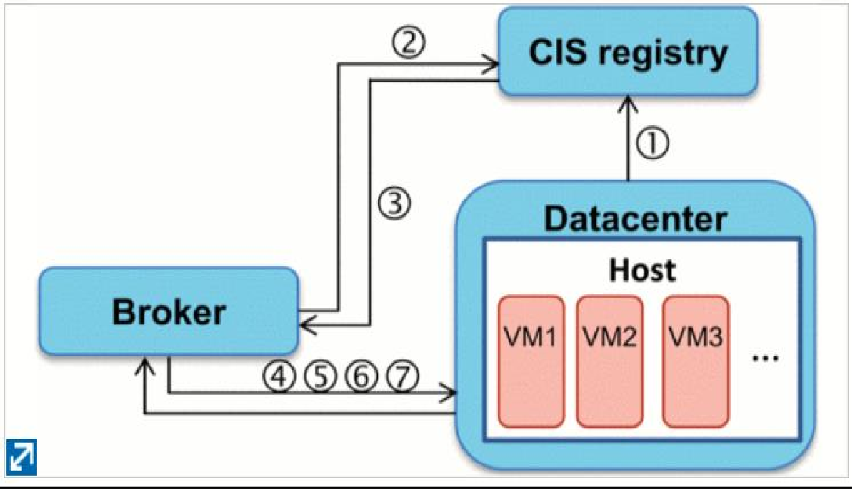
CloudSim is a well-known cloud computing simulator built upon GridSim. It has been developed in the CLOUDS Laboratory at the University of Melborne. It provides a toolkit for modelling and simulating the behaviour of many cloud components such as virtual machines (VMs), datacenter and resource provisioning services. Also, it can represent different types of clouds (public, private, hybrid and multi-cloud environments).
Fig 2: Flow of communication among cloudsim entities

CloudSim is an event-driven simulation tool, i.e., all components of the simulation maintain a message queue and generate messages, which they pass along to other entities. It can instantiate many datacenters which consists of storage servers and physical host machines. These machines host multiple VMs executing several tasks (named cloudlets). CloudSim can perform simulations of assigning and executing a workload on a cloud infrastructure. The communication flow among core CloudSim entities is shown in above fig.

FEATURES OF CLOUDSIM

Support for modelling and simulation of large-scale Cloud computing environments, including datacenters, on a single physical computing node (could be a desktop, laptop, or server machine).
A self-contained platform for modelling Clouds, service brokers, provisioning, and allocation policies.
Facilitates the simulation of network connections across the simulated system elements.
Facility for simulation of federated Cloud environment that inter-networks resources from both private and public domains, a feature critical for research studies related to Cloudbursts and automatic application scaling.Availability of a virtualization engine that facilitates the creation and management of multiple, independent, and co-hosted virtualized services on a datacenter node.
Flexibility to switch between space-shared and time-shared allocation of processing cores to virtualized services.
All these features would help in accelerating the development, testing and deployment of potential resource/application provisioning policies/algorithms for Cloud Computing based systems.

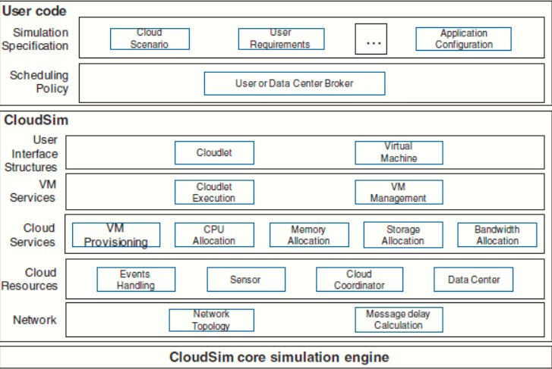
CLOUDSIM ARCHITECTURE

Fig 3: CloudSim core simulation engine

The above diagram demonstrates the layered architecture of CloudSim Simulation Toolkit. The CloudSim Core simulation engine provides support for modelling and simulation of virtualized Cloud-based datacenter environments including queuing and processing of events, creation of cloud system entities (like datacenter, host, virtual machines, brokers, services, etc.) communication between components and management of the simulation clock. The CloudSim layer provides dedicated management interfaces for Virtual Machines, memory, storage, and bandwidth. Also, it manages the other fundamental issues, such as provisioning of hoststo Virtual Machines, managing application execution, and monitoring dynamic system state (e.g. Network topology, sensors, storage characteristics, etc), etc. The user code layer is a custom layer where the user writes their own code to redefine the characteristics of the stimulating environment as per their new research findings.

DESIGN AND IMPLEMENTATION OF CLOUDSIM

In this section, we provide finer details related to the fundamental classes of CloudSim Simulation Toolkit (Version 3.0.3), which are also the building blocks of the simulator. The overall class design diagram for CloudSim is as

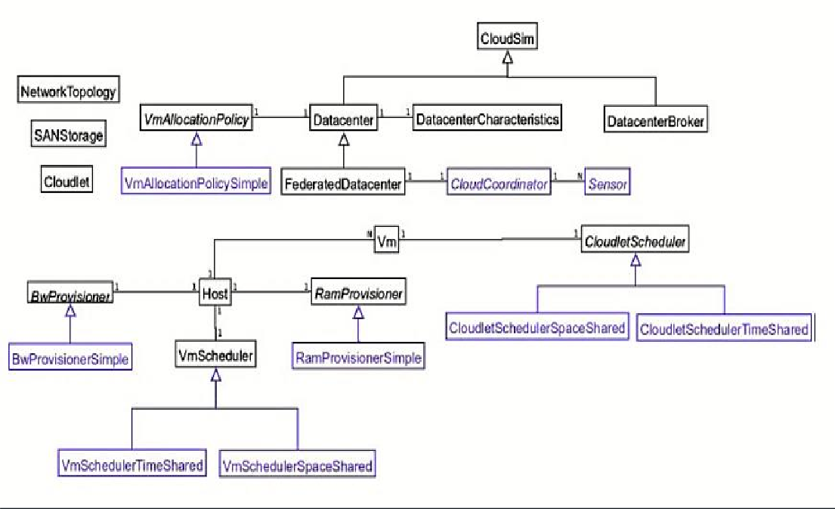
Fig 4: CloudSim class design diagram

The description of all the major classes mentioned in the class diagram above is described below:

- Cloudlet: This class model(define specific attributes such as length of instruction, input/output file size, no of processor required, etc) the Cloud- based application services (program based tasks) such as content delivery, social networking, etc. CloudSim implements the complexity of an application in terms of its computational requirements. As a developer, we know that every individual executable application/service workload has a pre-defined instruction length and requires certain network data flow (bothpre and post fetches) overhead that it needs to undertake during its life cycle. this class allows modelling all the above-said requirements.
- Cloudlet Scheduler: This is responsible for the implementation of different policies that determine the share of processing power among Cloudlets in a VM. There are two types of provisioning policies offered: space-shared (using Cloudlet Scheduler Space Shared class) and time-shared (using Cloudlet Scheduler Time Shared class).
- Datacenter: This class model the core infrastructure-level services (i.e., hardware) that are offered by Cloud providers (Amazon, Azure, and App Engine). It encapsulates a set of hosts (resembling server machine model) instances that can either be homogeneous or heterogeneous concerning their hardware configurations (memory, cores, capacity, and storage). Also, every Datacenter component takes care of generalized application provisioning that enforces a set of policies for the allocation of bandwidth, memory, and storage devices to hosts and its related VMs.
- Datacenter Broker or Cloud Broker: This class model a broker, which is responsible for mediating negotiations between SaaS and Cloud providers and such negotiations are driven by QoS requirements. The broker class acts on behalf of applications. Its prime role is to query the CIS to discover suitable resources/services and undertakes negotiations for the allocation of resources/services that can fulfill the application’s QoS needs. This class must be extended for evaluating and testing custom brokering policies.
- Datacenter Characteristics: This class contains configuration information of datacenter resources like the available host list, the fine-grained cost for each resource type, etc.
- Host: This class model a physical resource such as a computer or storage server. It encapsulates important information such as the amount of memory and storage, a list and type of processing cores (if it is a multi-core machine), an allocation of policy for provisioning the compute, memory and bandwidth to the VMs.
- Network Topology: This class contains the information for inducing network behavior (latencies) in the simulation. It stores the topology information, which is generated using the BRITE topology generator.
- Ram Provisioner: This is an abstract class that represents the provisioning policy for allocating primary memory (RAM) to Virtual Machines. Theexecution and deployment of VM on a host are feasible only if the Ram Provisioner component approves that the host has the required amount of free memory. The Ram Provisioner Simple does not enforce any limitation on the amount of memory that a VM may request. The RAM resource request will be rejected if it is beyond the available capacity.
- Bw Provisioner: The main role of this component is to undertake the allocation of network bandwidths to a set of competing VMs that are deployed across the datacenter. Cloud system developers and researchers can extend this class with their policies (priority, QoS) to reflect the needs of their applications.
- Vm: This class model a Virtual Machine (VM), which is managed and hosted by a Cloud host component. Every VM component has access to a component that stores the following characteristics related to a VM (i.e.) accessible memory, processor, storage size, and the VM’s internal provisioning policy that is extended from an abstract class called the Cloudlet Scheduler.
- Vm Allocation Policy: This is an abstract class that represents a provisioning policy to be utilized by VM Monitor for mapping VMs to hosts. The primary role is to select the best fit host in a datacenter that meets the memory, storage, and availability requirement for VM deployment mapping.
- Vm Scheduler: This is an abstract class implemented by a Host component that models the allocation policies (space-shared, time-shared) defining the rules for processor cores allocations to VMs. To accommodate application- specific processor sharing policies, the class functionality can be extended to define a new set of provisioning rules.
- CloudSim: This is the prime class, with the role of managing entity event queues and controlling the sequential execution of simulation events. Every event that is generated by the CloudSim entity at run-time is stored in the queue called future events. These events are sorted by their time parameters and are enqueued into the future queue. Next, the events that are scheduled at each step of the simulation are removed from the future events queue and transferred to the deferred event queue. Following this, an event processing method is invoked for each entity, which chooses events from the deferred event queue and performs appropriate actions. Such an organization allowsflexible management of simulation and provides the following powerful capabilities:
  - Deactivation (hold/pause) of entities.
  - Context switching of entities between different states (e.g. waiting to active). Pause and resume the process of simulation.
  - Creation of new entities at run-time.
  - Aborting and restarting simulation at run-time.

- FutureQueue: This class implements the future event queue accessed by CloudSim and acts as a ready queue to the simulation engine.
- DeferredQueue: This class implements the deferred event queue used by CloudSim and hold such events which are failed or paused. It acts as a wait queue of the simulation engine, where preempted resource requests are kept.
- CloudInformationService: A CIS is an entity that provides resource registration, indexing, and discovering capabilities. CIS supports two basic primitives:
- publish(), on the start of simulation it allows entities to register themselves with CIS
- search(), allows Brokers in discovering resources status and endpoint addresses of other entities. This entity also acts as a notification service to the other entities about the end of the simulation.
- SimEntity: This is an abstract class, which represents a simulation entity (such as DataCenter, DatacenterBroker, etc) that is able to send messages to other entities and processes received messages as well as fire and handle events. SimEntity class provides the ability to schedule new events and send messages to other entities, where network delay is calculated according to the BRITE model. Once created, entities automatically register with CIS.

All entities must extend this class and override its three core methods:
- startEntity(), which define actions for entity initialization.
- processEvent(), which defines actions processing of each called event(s) with respect to the entity.
- shutdownEntity(),which define actions for entity destruction.
- CloudSimTags. This class contains various static event/command tags that indicate the type of action that needs to be undertaken by CloudSim entities when they receive or send events.
- SimEvent: This entity represents a simulation event that is passed between two or more entities. SimEvent stores the following information about an event:
- type,

- init time,

- time at which the event should occur,

- finish time,

- time at which the event should be delivered to its destination entity,

- IDs of the source and destination entities,

- the tag of the event, and

- Data that have to be passed to the destination entity.

- CloudSimShutdown: This is an entity class that waits for the termination of all end-user submitted cloudlets(tasks) and broker entities events, and once detected, then signals the end of simulation to CIS.
Following is a very specific and important call hierarchy of classes which enables the CloudSim Simulation Toolkit to simulate the cloud computing environment, as demonstrated below:

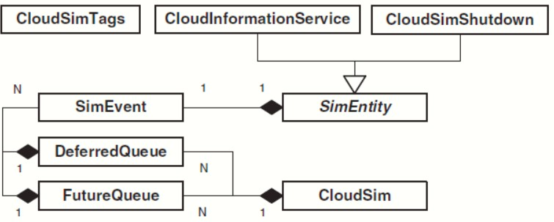

Fig 5: Call hierarchy of CloudSim classes

This hierarchy during the simulation iteratively calls a sequence of events to be performed with respect to the submitted Cloudlets, Datacenterborker policies and other relevant entities. The iteration stops when there are no more events left in FutureQueue/DeferredQueue instances.

CLOUD ANALYST

FEATURES OF THE SIMULATOR

There are several highly desirable features of a tool similar to the one described in the above section [17].

- Ease of use Ease of setting up and executing a simulation experiment is the main point of having a simulation tool. The simulator needs to provide an easy to use graphical user interface which is intuitive yet comprehensive.
- Ability to define a simulation with a high degree of configurability and flexibility Perhaps the most important feature is the level of configurability the tool can provide. A simulation, especially of the nature of modelling something as complex as an Internet Application depends on many parameters and most of the time the values for those parameters need to be assumed. Therefore, it is important to be able to enter and change those parameters quickly and easily and repeat simulations.
- Graphical output A picture is said to be worth a thousand words. Graphical output in the form of tables and charts is highly desirable to summarise the potentially large amount of statistics that is collected during the simulation. Such effective presentation helps in identifying the important patterns of the output parameters and helps in comparisons between related parameters.
- Repeatability Repeatability of experiments is a very important requirement of a simulator. The same experiment with the same parameters should produce similar results each time the simulation is executed. Otherwise the simulation becomes just a random sequence of events rather than a controlled experiment.
- It is also helpful to be able to save an experiment (the set of input parameters) as a file and also be able to save the results of an experiment as a file.Ease of extension as already mentioned simulating something like the Internet is a complex task and it is unlikely a 100% realistic simulation framework and a set of input parameters can be achieved in a few attempts. Therefore, the simulator is expected to evolve continuously rather than a program that is written once and for all and then used continuously. Therefore, the simulator architecture should support extensions with minimal effort with suitable frameworks.

SIMULATION OUTPUT / WHAT IS BEING MEASURED

Following are the statistical measures produced as output of the simulation in the initial version of the simulator. [17]

- Response time of the simulated application

  - Overall average, minimum and maximum response time of all user requests simulated.
  - The response time broken down by user groups, located within geographical regions.
  - The response time further broken down by the time showing the pattern of change over the duration of a day.
- The usage patterns of the application

  - How many users use the application at what time from different regions of the world, and the overall effect of that usage on the datacenters hosting the application
- The time taken by datacenters to service a user request

  - The overall request processing time for the entire simulation

  - The average, minimum and maximum request processing time by each datacenter
  - The response time variation pattern during the day as the load changes

- The cost of operation

CLOUDANALYST DOMAIN MODEL & MAIN COMPONENTS
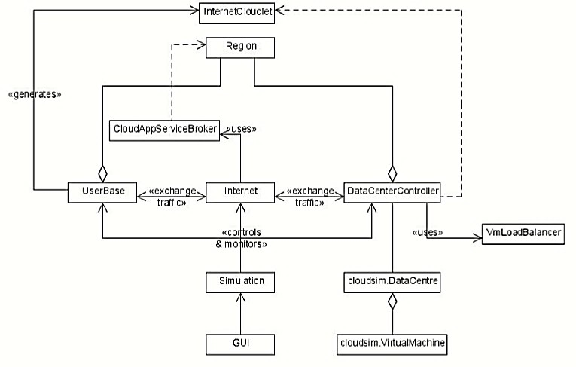
Fig 6: Cloud Analyst Domain

The following section describes these components and concepts in depth. The three main extensions introduced in CloudAnalyst to CloudSim toolkit are the User Base, Datacenter Controller and the Internet. But before explaining those it is appropriate to introduce the concept of “region”.

- Region: in the CloudAnalyst the world is divided in to 6 ‘Regions’ that coincide with the 6 main continents in the World. The other main entities such as User Bases and Datacenters belong to one of these regions. This geographical grouping is used to maintain a level of realistic simplicity for the large scaled simulation being attempted in the CloudAnalyst.
- Internet: The CloudAnalyst Internet is an abstraction for the real world Internet, implementing only the features that are important to the simulation. It models the Internet traffic routing around the globe by introducing suitable transmission latency and data transfer delays. The transmission latency and the available bandwidth between the 6 regions are configurable.
- Cloud Application Service Broker: The traffic routing between User Bases and Datacenters is controlled by a Service Broker that decides which Datacenter should service the requests from each user base. Current version
- of CloudAnalyst implements three types of service brokers each implementing a different routing policy. 1. Service Proximity based routing. In this case the proximity is the quickest path to the datacenter from a user base based on network latency. The service broker will route user traffic to the closest datacenter in terms of transmission latency. 2. Performance Optimized routing Here the Service Broker actively monitors the performance of all datacenters and directs traffic to the datacenter it estimates to give the best response time to the end user at the time it is queried. 3. Dynamically reconfiguring router This is an extension to Proximity based routing, where the routing logic is very similar, but the service broker is entrusted with the additional responsibility of scaling the application deployment based on the load it is facing. This is done by increasing or decreasing the number of VMs allocated in the datacenter, according to the current processing times as compared against best processing time ever achieved. The implementation of Service Broker policies is discussed in detail in section 3.5.2.
- User Base: A User Base models a group of users that is considered as a single unit in the simulation and its main responsibility is to generate traffic for the simulation. A single User Base may represent thousands of users but is configured as a single unit and the traffic generated in simultaneous bursts representative of the size of the user base. The modeller may choose to use a User Base to represent a single user, but ideally a User Base should be used to represent a larger number of users for the efficiency of simulation.
- InternetCloudlet: An InternetCloudlet is a grouping of user requests. The number of requests bundled into a single InternetCloudlet is configurable in CloudAnalyst. The InternetCloudlet carries information such as the size of a request execution command, size of input and output files, the originator and target application id used for routing by the Internet and the number of requests.
- Datacenter Controller: The Datacenter Controller is probably the most important entity in the CloudAnalyst. A single Datacenter Controller is mapped to a single cloudsim.DataCenter object and manages the datacenter management activities such as VM creation and destruction and does the routing of user requests received from User Bases via the Internet to theVMs. It can also be viewed as the façade used by CloudAnalyst to access the heart of CloudSim toolkit functionality.
- VmLoadBalancer: The Datacenter Controller uses a VmLoadBalancer to determine which VM should be assigned the next Cloudlet for processing. Currently there are three VmLoadBalancers implementing three load balancing policies which can be selected as required by the modeller. 1. Round-robin Load Balancer – uses a simple round-robin algorithm to allocate VMs 2. Active Monitoring Load Balancer – this version load balances the tasks among available VM's in a way to even out the number of active tasks on each VM at any given time. 3. Throttled Load Balancer – this ensures only a pre-defined number of Internet Cloudlets are allocated to a single VM at any given time. If more request groups are present than the number of available VM’s at a datacenter, some of the requests will have to be queued until the next VM becomes available.
- GUI: The GUI is implemented as a set of screens that enable the user to: 1. Define the Simulation parameters a. Define in detail the characteristics of a Datacenter including the detailed hardware specification of the server farmb. Define application deployment specifications such as how many virtual machines should be allocated in which datacenters and the detailed specification of those virtual machines c. Define the user bases and their characteristics such as the number of users, the peak and off-peak hours of usage and the frequency of traffic generation d. Define Internet specific characteristics including network latency and available bandwidth e. Simulator performance related parameters such as grouping factors for user requests when messages are sent from UserBases and when messages are assigned to Virtual Machines in the Datacenter 2. Save and load simulation configurations 3. Execute simulations with the option of cancelling a simulation once started 4. View and save the results of the simulation with graphical outputs where appropriate. [18]

CLASS DESIGN

The following class diagram describes the main set of classes of the CloudAnalyst. These classes are responsible for the modelling and execution of the simulations. The GUI is designed loosely coupled from this main simulation framework and hence shown as a package in the main diagram but expanded and displayed in detail in the next diagram.The classes UserBase, Internet and DataCenterController all extend the clousim.CloudSim class from the CloudSim toolkit and are active simulation entities that run as separate threads. The rest of the DataCenter functionality (VM management, task execution) is called by the DataCenterController via the cloudsim.DataCenter.
The main classes and their responsibilities are as follows:

- GuiMain – The main class of the GUI. Displays the GUI and acts as the front-end controller for the application managing screen transitions and other UI activities.
- Simulation – Responsible for holding the simulation parameters and creating and executing the simulation.
- UserBase – Models a user base and generates traffic representing the users.
- DataCenterController – Controls the datacenter activities as explained above.
- Internet – Models the Internet and implements the traffic routing behaviour.
- InternetCharacteristics – Maintains the characteristics of the internet including the latencies and available bandwidths between regions, the current traffic levels and current performance level information for the datacenters.
- CloudAppServiceBroker and its implementations – Models the service brokers
- VmLoadBalancer and its implementations – Models the load balancing logic used by datacenters in allocating requests to VMs.
- UserBaseUIElement, DataCenterUIElement, MachineUIElement – holds information about user bases, datacenters and machines for the UI until Simulation use them to create the respective simulation entities. [19]

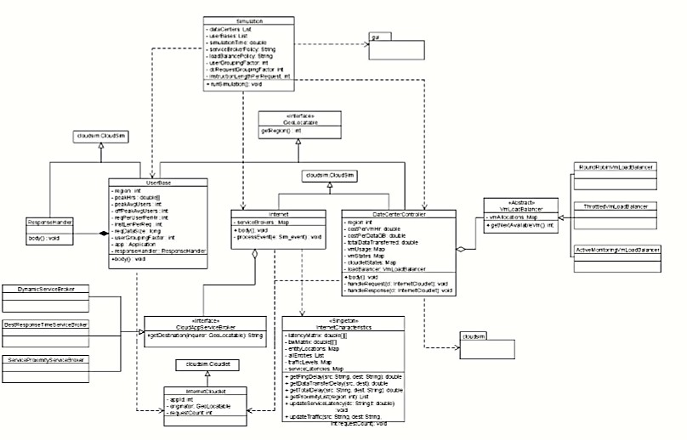

Fig 7: Class Diagram Showing the Main Classes of CloudAnalyst

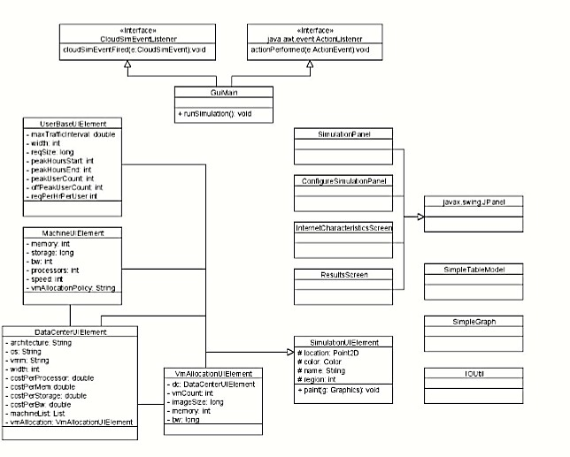

Fig 8: Cloud Analyst GUI Class Diagram

VM LOAD BALANCING ALGORITHM

The datacenters use the VMLoadBalancer to load balance requests between the available virtual machines, and in the current version there are 3 variants. The first – round-robin is straight forward and is not explained further here. The algorithms used in the other two are explained below.

- Throttled Load Balancer
Following is the algorithm used by the ThrottledVmLoadBalancer:

  - ThrottledVmLoadBalancer maintains an index table of VMs and the state of the VM (BUSY/AVAILABLE). At the start all VM’s are available.
  - DataCenterController receives a new request.

  - DataCenterController queries the ThrottledVmLoadBalancer for the next allocation.
  - ThrottledVmLoadBalancer parses the allocation table from top until the first available VM is found or the table is parsed completely.

If found:

    - The ThrottledVmLoadBalancer returns the VM id to the DataCenterController
    - The DataCenterController sends the request to the VM identified by that id.
    - DataCenterController notifies the ThrottledVmLoadBalancer of the new allocation
    - ThrottledVmLoadBalancer updates the allocation table accordingly

If not found:

    - The ThrottledVmLoadBalancer returns -1.
    - The DataCenterController queues the request

  - When the VM finishes processing the request, and the DataCenerController receives the response cloudlet, it notifies the ThrottledVmLoadBalancer of the VM de-allocation.
  - The DataCenerController checks if there are any waiting requests in the queue. If there are, it continues from step 3.
  - Continue from step 2.

The throttling threshold maintained by this algorithm is 1. It can be modified easily to make the threshold a configurable value.
- Active Monitoring Load Balancer

This load balancing policy attempts to maintain equal workloads on all the available VMs. The algorithm used is quite similar to the throttled case:
  - ActiveVmLoadBalancer maintains an index table of VMs and the number of requests currently allocated to the VM. At the start all VM’s have 0 allocations.
  - When a request to allocate a new VM from the DataCenterController arrives, it parses the table and identifies the least loaded VM. If there are more than one, the first identified is selected.
  - ActiveVmLoadBalancer returns the VM id to the DataCenterController

  - The DataCenterController sends the request to the VM identified by that id.
  - DataCenterController notifies the ActiveVmLoadBalancer of the new allocation
  - ActiveVmLoadBalancer updates the allocation table increasing the allocations count for that VM.
  - When the VM finishes processing the request, and the DataCenerController receives the response cloudlet, it notifies the ActiveVmLoadBalancer of the VM de-allocation.
  - The ActiveVmLoadBalancer updates the allocation table by decreasing the allocation count for the VM by one. Continue from step 2. [20]

SERVICE BROKER ALGORITHMS

Currently there are 3 different implementations of Service Broker.

- Service Proximity Based Routing
This is the simplest Service Broker implementation.
  - ServiceProximityServiceBroker maintains an index table of all Datacenters indexed by their region.
  - When the Internet receives a message from a user base it queries the ServiceProximityServiceBroker for the destination DataCenterController.
  - The ServiceProximityServiceBroker retrieves the region of the sender of the request and queries for the region proximity list for that region from the InternetCharacteristics. This list orders the remaining regions in the order of lowest network latency first when calculated from the given region.
  - The ServiceProximityServiceBroker picks the first datacenter located at the earliest/highest region in the proximity list. If more than one datacenter is located in a region, one is selected randomly.
- Performance Optimized Routing

  - This policy is implemented by the BestResponseTimeServiceBroker, which extends the ServiceProximityServiceBroker.
  - BestResponseTimeServiceBroker maintains an index of all Datacenters available.
  - When the Internet receives a message from a user base it queries the BestResponseTimeServiceBroker for the destination DataCenterController.
  - The BestResponseTimeServiceBroker identifies the closest (in terms of latency) datacenter using the ServiceProximityServiceBroker algorithm.
  - Then the BestResponseTimeServiceBroker iterates through the list of all datacenters and estimates the current response time at each datacenter by
    - Querying the last recorded processing time from InternetCharacteristics.
    - If this time is recorded before a predefined threshold, the processing time for that datacenter is reset to 0. This means the datacenter has been idle for a duration of at least the threshold time.
    - The network delay from InternetCharacteristics is added to the value arrived at by above steps.
  - If the least estimated response time is for the closest datacenter, the BestResponseTimeServiceBroker selects the closest datacenter. Else, BestResponseTimeServiceBroker picks either the closest datacenter or the datacenter with the least response time with a 50:50 chance (i.e. load balanced 50:50). All the algorithms mentioned so far in this section are just the initial versions of the algorithms. These can be further improved with more testing.
- Dynamic Service Broker

  - Currently the Dynamic Service Broker is not fully implemented.

CONFIGURE SIMULATION SCREEN

- Main Tab

The configuration options on the main tab are:

  - Simulation time – the duration of the simulation which can be given in minutes, hours or days
  - User Bases Table – This is a table listing out all the user bases in the simulation. Each user base has following configurable fields, represented by a single row in the table.
    - Name
    - Region
    - Requests per user per hour
    - Data size per request
    - Peak hours
    - Average users during peak hours
    - Average users during off-peak hours

The Add and Remove buttons next to the table can be used to add or remove user bases from the configuration. [22]

  - Application Deployment Configuration – This table lists how many virtual machines are allocated for the application in each datacenter from the Datacenters tab, along with the details of a virtual machine. The fields are:

    - Datacenter – This is a drop down listing the names of datacenters created in the Datacentertab.
    - Number of VMs – How many VMs to be allocated to the application from the selected datacenter
    - Image Size – a single VM image size in bytes
    - Memory – amount of memory available to a single VM
    - BW – amount of bandwidth available to a single VM
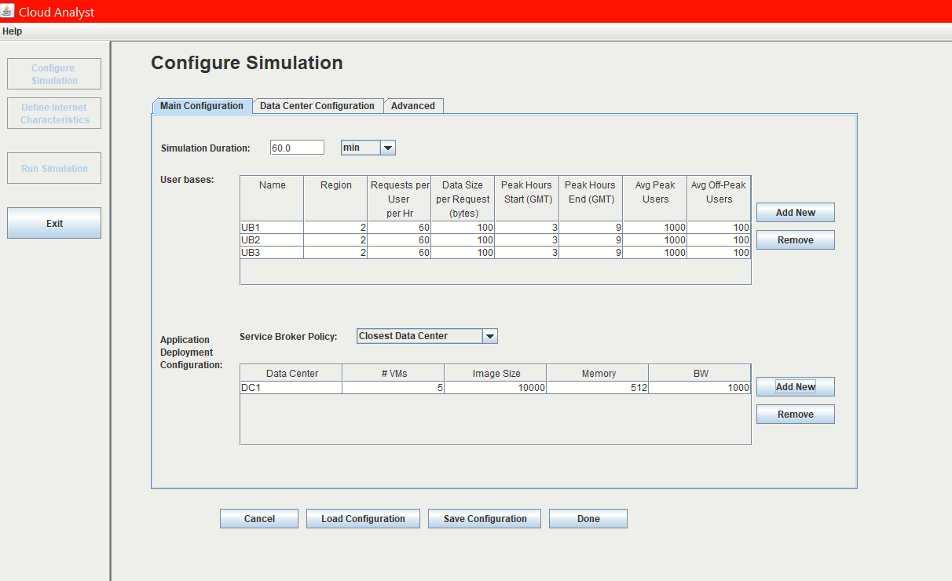

Fig 9: Configure Simulation Screen- Main Tab

  - Service Broker Policy – This drop down allows you to select the brokerage policy between datacenters that decide which datacenter should receive traffic from which user base. The available policies are:
    - Closest datacenter – The datacenter with the least network latency (disregarding network bandwidth) from a particular user base is sent all the requests from that user base.
    - Optimize response time – This policy attempts to balance the load between datacenters when one datacenter gets over loaded.
The “Save Configuration” button allows you to save the configuration created as a file. Simulation files are saved with a. sim extension. Similarly using the “Load Configuration” button you can load a previously saved simulation configuration .

- Datacenter Tab
The datacenter tab allows you to define the configuration of a datacenter (see Figure 8 below). The table at the top lists the datacenters and using the Add/Remove buttons you can add or remove datacenters to the configuration. The parameter fields are:
  - Name
  - Region
  - Architecture – Architecture of the servers used in the datacenter. e.g. X86
  - Operating System – e.g. Linux
  - Virtual Machine Monitor (VMM)
  - Cost per VM Hour
  - Cost per 1Mb Memory Hour
  - Storage cost per Gb
  - Data Transfer cost per Gb (both in and out)
  - Number of servers

When you select a datacenter from this table a second table will appear below it with the details of the server machines in the datacenter. The parameters for each machine can be given according to the available fields. [24]
  - Machine Id

  - Memory

  - Storage

  - Available network bandwidth.

  - Number of processors

  - Processor speed (MIPS)

  - VM allocation policy (time shared/space shared)
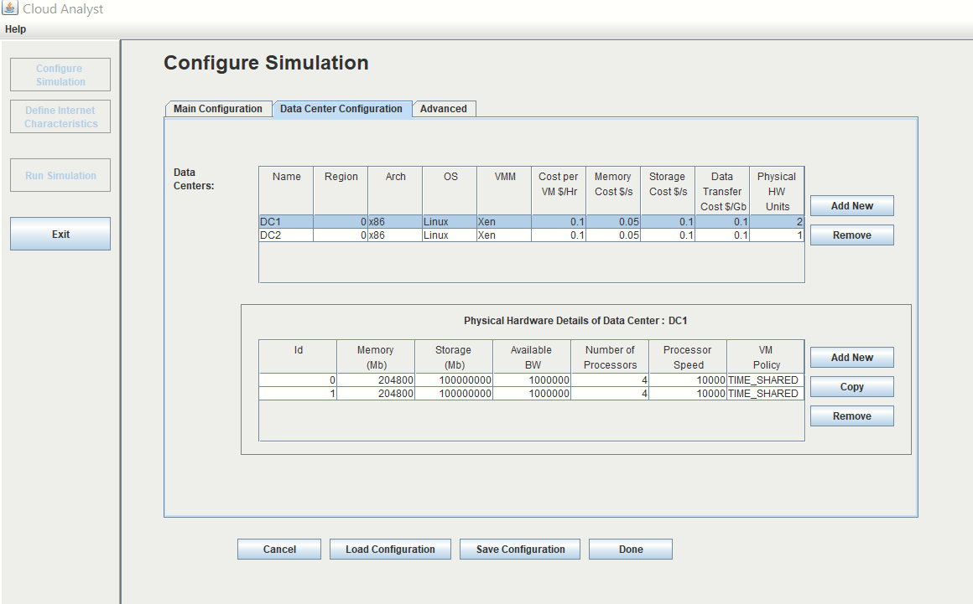
Fig 10: Configure Simulation Screen- Datacenter

- Advanced Tab

The advanced tab contains some important parameters that apply to the entire simulation.
  - User Grouping Factor (in User Bases) – This parameter tells the simulator how many users should be treated as a single bundle for traffic generation. The number given here will be used as the number of requests represented by a single InternetCloudlet.
  - In the ideal scenario this parameter should be 1, with each individual user represented independently. But that will increase the simulation time unrealistically.
  - Request Grouping Factor (in Datacenters) – This parameter tells the simulator how many requests should be treated as a single unit for processing. i.e. this many requests are bundled together and assigned to a single VM as a unit.
  - Again, ideally this should be equal to 1. But it could also be viewed as the number of simultaneous threads a single application instance (VM) can handle.
  - Executable instruction length (in bytes) – This is the main parameter that affects the execution length of a request. This is the same GridletLength parameter used in GridSim.
  - Load balancing policy – the load balancing policy used by all datacenters in allocating requests to virtual machines. Available policies are:
    - Round-robin
    - Equally Spread Current Execution Load – The load balancer keeps track of how many Cloudlets are currently being processed by each VM and tries to even out the active load.
    - Throttled – The load balancer throttles the number of requests assigned to a single VM.
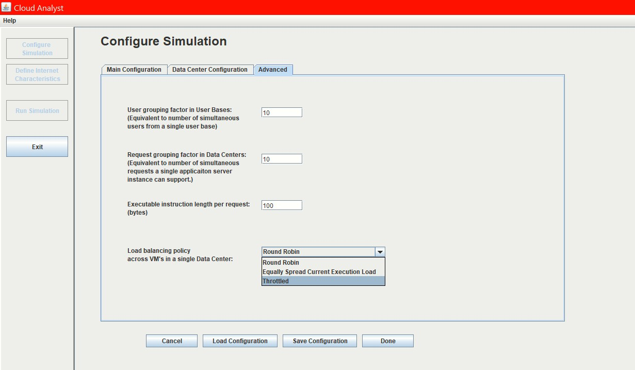
Fig 11: Configure Simulation Screen-Advance Tab

- Internet Characteristics Screen

The Internet Characteristics screen can be used to set the Internet latency and bandwidth parameters. It presents two matrices for these two categories.
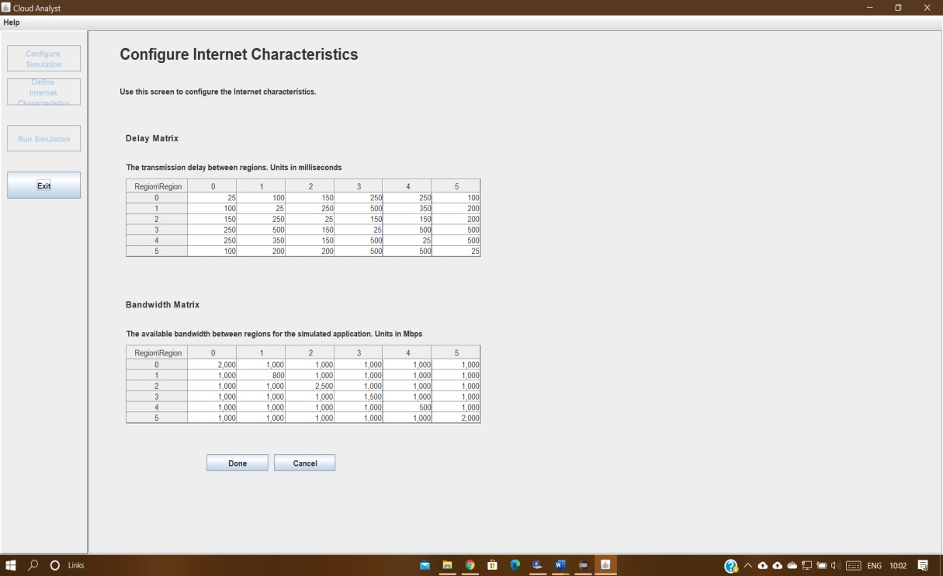

Fig 12: Internet Characteristics Screen

PREVIOUS WORK

OVERVIEW

Aim for the previous year was to configure the cloud simulation environment, implementing and testing genetic algorithm, to introduce a new task scheduling algorithm in the cloud environment and to compare the introduced algorithm with all the other primitive algorithms in CloudSim with respect to time and cost. This section reviews all the work that has been completed in the previous year, describing each task/aim of the project mentioned in the previous paragraph..

ALGORITHM USED

SHORTEST JOB FIRST

Shortest Job First Scheduling Algorithm SJF Algorithm is a pre-emptive that selects the waiting process that has the least execution time. The process is then allocated to the processor that has the least burst time.

Fig: Shortest Job First Algorithm

GENETIC ALGORITHM

Genetic Algorithms (GAs) are adaptive heuristic search algorithms that belong to the larger part of evolutionary algorithms. Genetic algorithms are based on the ideas of natural selection and genetics. These are intelligent exploitation of random search provided with historical data to direct the search into the region of better performance in solution space. They are commonly used to generate high-quality solutions for optimization problems and search problems. Genetic algorithms simulate the process of natural selection which means those species who can adapt to changes in their environment are able to survive and reproduce and go to next generation. In simple words, they simulate “survival of the fittest” among individual of consecutive generation for solving a problem.

Fig : Genetic Algorithm Flowchart

PREVIOUS RESULTS

COMPARISON

Fig: Comparison Table of All The Algorithms

Fig : Comparison Graph Of All Algorithms

OVERVIEW OF PROPOSED ALGORITHM

Applying Genetic Algorithm for task scheduling we have seen that it has reduced the total time , makespan time and overall cost of all the processess. Now we are applying Consensus Algorithm which is a part of Blockchain Architecture to this Genetic Algorithm which will increase both the efficiency of cost and time.The Bitcoin in Consensus Algorithm will we replaced by cloudlets and will optimised the task scheduling more efficiently

CONSENSUS ALGORITHM

A consensus algorithm is like Bitcoin’s PoW (Proof-of- Work), which requires miners to solve complex cryptographic mathematical puzzles for which they get rewarded with certain amount of Bitcoins. It is important to understand that each block which is added to the network must follow a set of consensus rules. E.g. Bitcoin’s consensus rules are no double spending, correct format of blocks, a certain amount of reward for miners etc. Blocks that fail to follow these consensus rules will be rejected. A blend of PoW consensus algorithms and the consensus rules offers a strong and reliable network which is secure and ensures that all the nodes in the network agree on a regular global state of the blockchain.

FEATURES OF CONSENSUS PROTOCOL

A consensus protocol has 3 basic features based on which its efficiency can be determined.

- Security: A consensus protocol is defined to be safe if all the nodes offer same output and the outputs are valid as per the rules. This is also called as consistency of the shared state.

- Real Time Value: A consensus protocol ensures real-time liveness, if all correct nodes participating in consensus eventually produce a value.

- Fault Tolerance: A consensus protocol offers fault tolerance, if it can recover from a failure of a node participating in consensus.

PROOF-OF-WORK(POW)

PoW is currently the most common and one of the most robust consensus mechanism for blockchain technology. The miner has to solve mathematically complex puzzles on the new block before approving the block to the ledger. After solving the puzzle, the solution is then forwarded to other miners and verified by them before being accepted to their respective copies of the ledger. The PoW method defines that the nodes must adopt the fork which carries work, and it is very unlikely that the two competing forks will generate the next block together. Blockchain core network protects against double-spending by the verification of each transaction with the use of Proof-of-Work (PoW) mechanism. Transactions are finalized and approved by the minors after verification. If anyone tries to duplicate a transaction, it will show in the network that it is counterfeit and would not be accepted. You can’t double spend, once a transaction is approved.

PROOF -OF -STAKE(POS)

PoS is a substitute approach for PoW which requires fewer CPU computations for mining. Though this is also an algorithm, and the purpose is same as PoW, the process is quite different here. As in case of PoW, a miner is rewarded by resolving mathematical problems and creating new blocks, in Proof-of- Stake, the creator of a new block is chosen in a deterministic way, depending on its wealth, also defined as stake. This means that in the PoS mechanism, there is no block reward. So, the miners take the transaction fees. PoS mechanism has its own pros and cons, and the actual implementations are quite complex.

REFERENCES

- Blockchain A Practical Guide to Developing Business, Law, and Technology Solutions Joseph J. Bambara Paul R. Allen

- https://www.digitalocean.com/community/tutorials/a-general-introduction-to-cloud-computing

- https://blockchainhub.net/blockchain-intro/#:~:text=Double%2DSpending%20Problem%3A%20The%20way,computers%20at%20the%20same%20time.

- https://csrc.nist.gov/publications/detail/sp/800-145/final

- Journal of King Saud University - Computer and Information Sciences

- https://ktconnections.com/about-us/165-cloud-computing-definition

- Cloud Computing Models by Eugene Gorelik Submitted to the MIT Sloan School of Management and the MIT Engineering Systems Division in Partial Fulfillment of the Requirements for the Degrees

- https://phoenixnap.com/blog/cloud-deployment-models

- https://itchronicles.com/cloud/the-evolution-of-cloud-computing-wheres-it-going-next/

- https://www.zdnet.com/article/what-is-cloud-computing-everything-you-need-to-know-about-the-cloud/

- https://cacm.acm.org/magazines/2010/4/81493-a-view-of-cloud-computing/fulltext

- https://www.znetlive.com/blog/what-is-load-balancing-in-cloud-computing-and-its-advantages/

- https://www.bankrate.com/glossary/b/blockchain/

- https://onlinecourses.nptel.ac.in/noc21_cs15/preview

- https://whatis.techtarget.com/definition/consensus-algorithm#:~:text=A%20consensus%20algorithm%20is%20a,network%20involving%20multiple%20unreliable%20nodes.&text=As%20a%20result%2C%20consensus%20algorithms%20must%20be%20fault%2Dtolerant.

- https://www.opensourceforu.com/2014/03/cloudsim-framework-modelling-simulating-cloud-environment/#:~:text=The%20CloudSim%20Framework%3A%20Modelling%20and%20Simulating%20the%20Cloud%20Environment&text=CloudSim%20provides%20a%20generalised%20and,and%20simulation%20of%20app%20performance.
- Analysis of Load Balancing Algorithms using Cloud Analyst Simar Preet Singh1 , Anju Sharma2 and Rajesh Kumar3 1,2,3Thapar University, Patiala-147004, India

- http://www.cloudbus.org/cloudsim/

- https://www.google.com/search?q=cloudsim+in+cloud+computing&rlz=1C1GCEA_enIN847IN847&oq=cloudsim&aqs=chrome.3.69i59l2j69i57j0i20i263l2j0i67l2j0j0i67l2.6998j0j15&sourceid=chrome&ie=UTF-8

- CloudAnalyst: A CloudSim-based Tool for Modelling and Analysis of Large Scale Cloud Computing Environments MEDC Project Report

- https://www.botmetric.com/blog/aws-cloud-architecture-design-principles/

- http://www.ijoart.org/docs/A-Survey-of-Load-Balancing-Algorithms-using-VM.pdf

